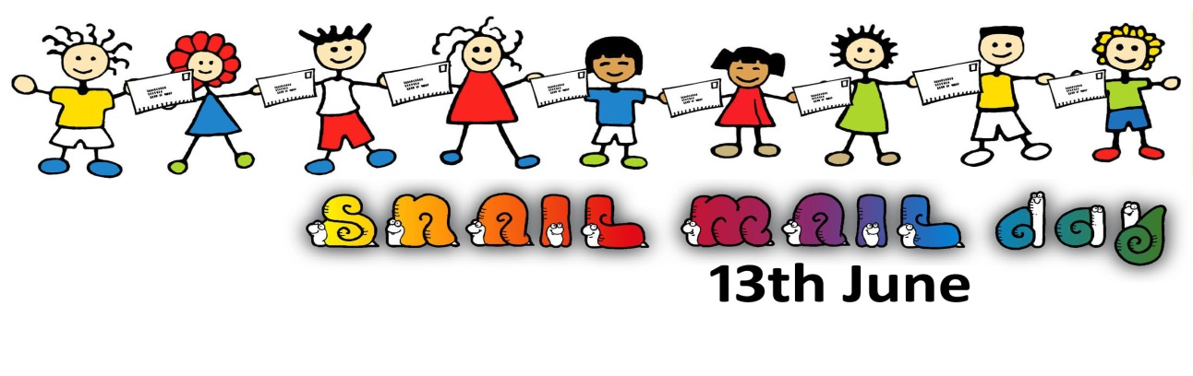
SNAIL MAIL Day - Send 'Nyone An Interesting Letter - 13th June is a day to encourage everyone throughout the country to send a card or letter. Remember the feeling of delight at getting a real letter? Children need to experience this also, as well as knowing that sending a card or letter can makes someone’s day. While technology is a wonderful tool, a text or email won’t last forever, while a letter can. Letters are a way to preserve our history. As a children’s author, it concerns me that our children are losing the skill of letter writing. If this is the case, we need to make sure we keep this alive for them.
The idea for Snail Mail Day came to me while watching my oldest daughter and her friend reading letters they’d written to one another as young teenagers. I knew something had to be done to preserve our history and keep this form of communication alive.
For adults check out Facebook SNAIL MAIL Day 13th June
For children there is a Snail Mail Day page on my website at www.rainbowpoetry.co.nz
A poster for the day can also be downloaded here.
Schools and libraries are joining in, but I need help to spread the word further afield, so if you like the idea please tell others.
Judi Billcliff from Rainbow poetry rainbowpoetry@gmail.com

