FOXES by Emily

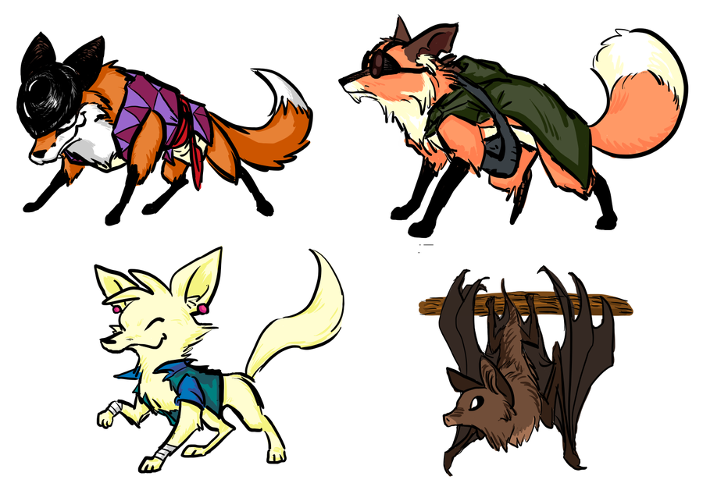
Foxes
Paws running
Pouching
Growling
Digging

© Emily 2015

